Experiment

Design a digital data display system

Circuit diagram:

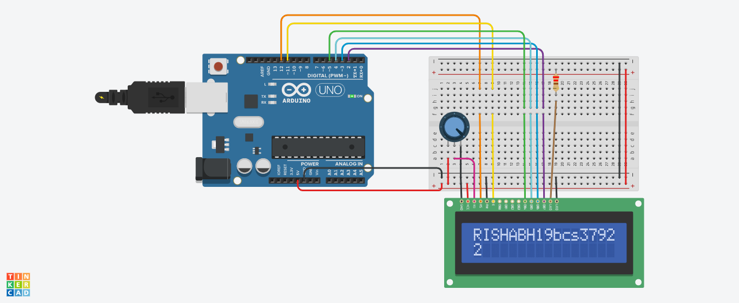

**Theory:**

# CONCEPT USED:

* **By using kirchoff’s voltage law**

&

* **By using kirchoff’s current law**
* **Use of digital data display system**
* **Use of LCD**
* **Use of potentiometer**

# LEARNING AND OBSERVATIONS:

* **Connections in Breadboard and wiring.**
* **How to control arduino and its coding.**
* **Use of multimeter for continuity.**
* **Use of potentiometer**
* **Liquid crystal display**

**OBSERVATION:**

* **Observation of programme on display**
* **Relation between software and hardware.**
* **Variation of resistance i.e. potentiometer**

# PROBLEMS & TROUBLESHOOTING:

* **To select the right port and type of arduino**
* **To check the loose connections**
* **To check the connections according to the codes**
* **To check the continuity of the circuit**
* **To check the flow of current in the circuit**
* **Errors in code**
* **Setting up right connections**
* **Display in proper order**
* **Pinmodes of LCD**

# PRECAUTIONS:

* **Handle tools carefully**
* **Wear gloves**
* **Do not connect arduino till the circuit is complete**
* **Do not connect LCD without a variable resistor**

# OUTCOMES:

* **Display our command as digital data output**
* **Proper use of Arduino and breadboard**

**Created By-**

**Name: RISHABH GUPTA**

**ROLL NO: 19BCS3792**

**Stream: CSE(BD1 B)**

**University: CHANDIGARH UNIVERSITY**